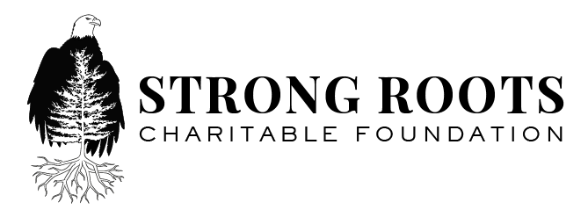
76 Geronimo Lane
Hogansburg, New York 13655
Phone: (518) 358-6072 • Fax: (518) 358-3637

The Strong Roots Charitable Foundation provides support to
empower and enrich the lives of Akwesasne youth and elders.

Potential Partner,
Strong Roots Charitable Foundation, Inc. is a recently established Public Charity determined by the IRS to be exempt from Federal Income Tax under Internal Revenue Code (IRS Section 501(c) (3). Strong Roots Charitable Foundation was created with the purpose of shaping the future of the Akwesasne community by growing our youth into future leaders in a healthy and safe environment. The foundation is designed to provide a funding stream to help address needs within our community that focus on our youth, our elders, and our overall health and safety. We work to fulfill community-based projects that greatly improve the quality of life for our residents. A few of the projects to date include; the construction of a roof over the outdoor arena at Generations Park; the purchasing of fitness equipment for the youth, and the construction of a sweat lodge, the construction of a vestibule at the Akwesasne Cultural Center Museum.
The Strong Roots Foundation is pleased to issue this RFP for a community capital project—a new construction, expansion, renovation, or replacement project for an existing facility or space that addresses the youth or elders with a focus on safety and health. Strong Roots seeks to generate proposals that actively address gaps and needs affecting the youth and elders to better equip them to meet the rapidly changing demands and challenges in the new millennium.
Applicants with projects that seek to improve the Akwesasne community in line with the criteria outlined will be invited to submit a proposal to the Executive Director of the Strong Roots Charitable Foundation. Included in the proposal, they will need to describe their community project and detail how their project will fulfill the following criteria:
- Has the potential to affect 100 community members or more
- Has the potential to improve “Quality of Life” for Akwesasne Youth or Elders
- Involves partnering with other community leadership boards for the success of the project
- Fills a long-standing, identifiable need within the community
- Has the capacity for fulfilling project scope of work and project goals; including supporting the maintenance of the project after completion
- Is resourceful and utilizes existing assets and resources in the community
Impact: Describe how the project will make a significant, sustainable difference now and in the future. Will the project inspire or inform other segments of the community? Is the project innovative, thoughtful, and realistic in addressing a need? Does the project propose to make a breakthrough in addressing a need?
Stages for Review:
- Initial Review- The Executive Committee will evaluate proposals and select the top applicants based on the criteria listed above.
- Finalist Review- The Executive Committee will invite the top applicants to meet and make a presentation on July 8th addressing any additional questions or considerations that they may have if needed.
- Announcement of Winning Proposal- An announcement of the selected project at the 4th Annual Strong Roots Charity Cup on July 12th 2019.
All proposals must be typed and submitted by June 28th at 4pm to april.lauzon@caamgmt.com
Any submissions after this time will not be considered. Any questions pertaining to the RFP can be directed to April Lauzon via the email address above or by phone at 518-358-6072.

